CST8921 – Cloud Industry Trends
  - Lab 3 – Cosmos db change feed
Lab Activity Overview:
Process change feed events using the Azure Cosmos DB for NoSQL SDK

In this lab, you will use the change feed processor functionality in the .NET SDK to create an application that is notified with a create or update operation is performed on an item in the specified container.

- Start Visual Studio Code.
- Open the command palette and run Git: Clone to clone the https://github.com/microsoftlearning/dp-420-cosmos-db-dev GitHub repository in a local folder of your choice.
- Once the repository has been cloned, open the local folder you selected in Visual Studio Code.
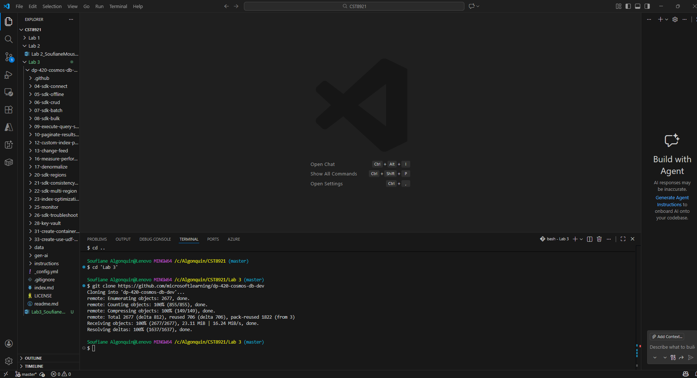
- Create a azure cosmos db for nosql account. Choose capacity mode as serverless.
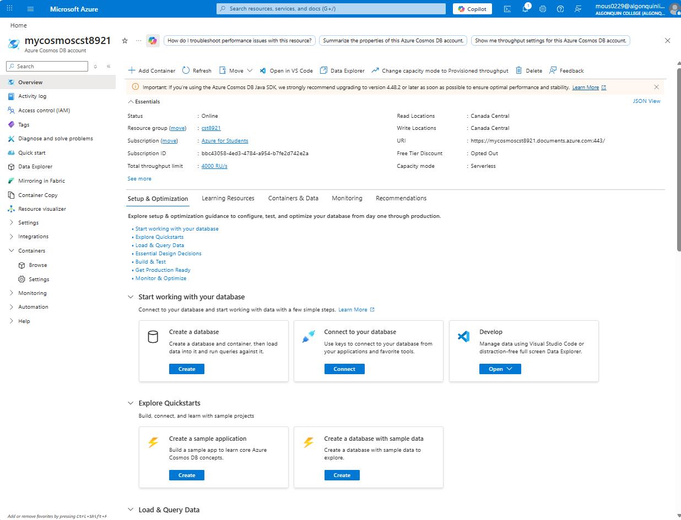
- Review keys pane in cosmosdb account and notice the connection details and credentials to connect the account from sdk.
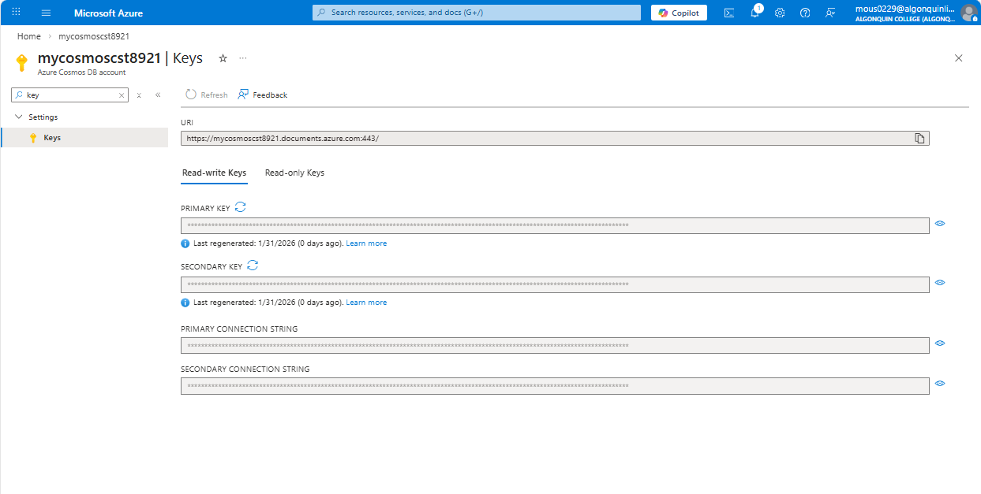
- In data explorer, expand new container and select new database.
- In new database popup, enter “cosmicworks” value in database id.
- In data explorer pane, select new container and enter following values:
Setting | Value
Database id | Use existing | cosmicworks
Container id | products
Partition key | /categoryId
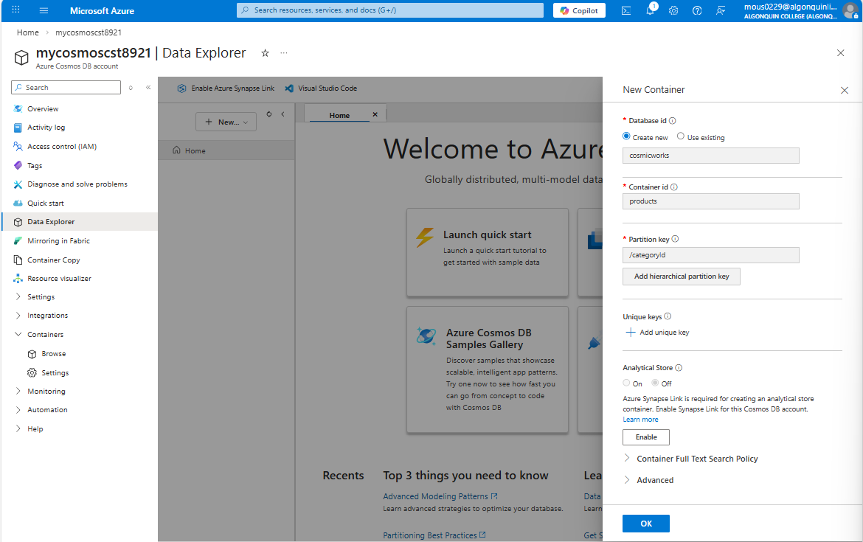

- Create another container with the following values:

Setting | Value
Database id | Use existing | cosmicworks
Container id | productslease
Partition key | /partitionKey

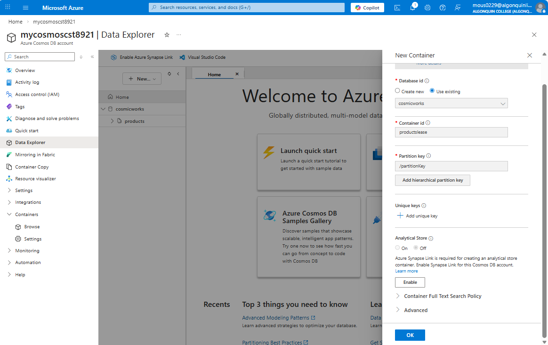
- Return to visual studio.
- In the Explorer pane, browse to the 13-change-feed folder.
- Open the product.cs code file.
- Observe the Product class and its corresponding properties. Specifically, this lab will use the id and name properties.
- Back in the Explorer pane of Visual Studio Code, open the script.cs code file.
- Update the existing variable named endpoint with its value set to the endpoint of the Azure Cosmos DB account you created earlier.
string endpoint = "<cosmos-endpoint>";

- Update the existing variable named key with its value set to the key of the Azure Cosmos DB account you created earlier.
string key = "<cosmos-key>";
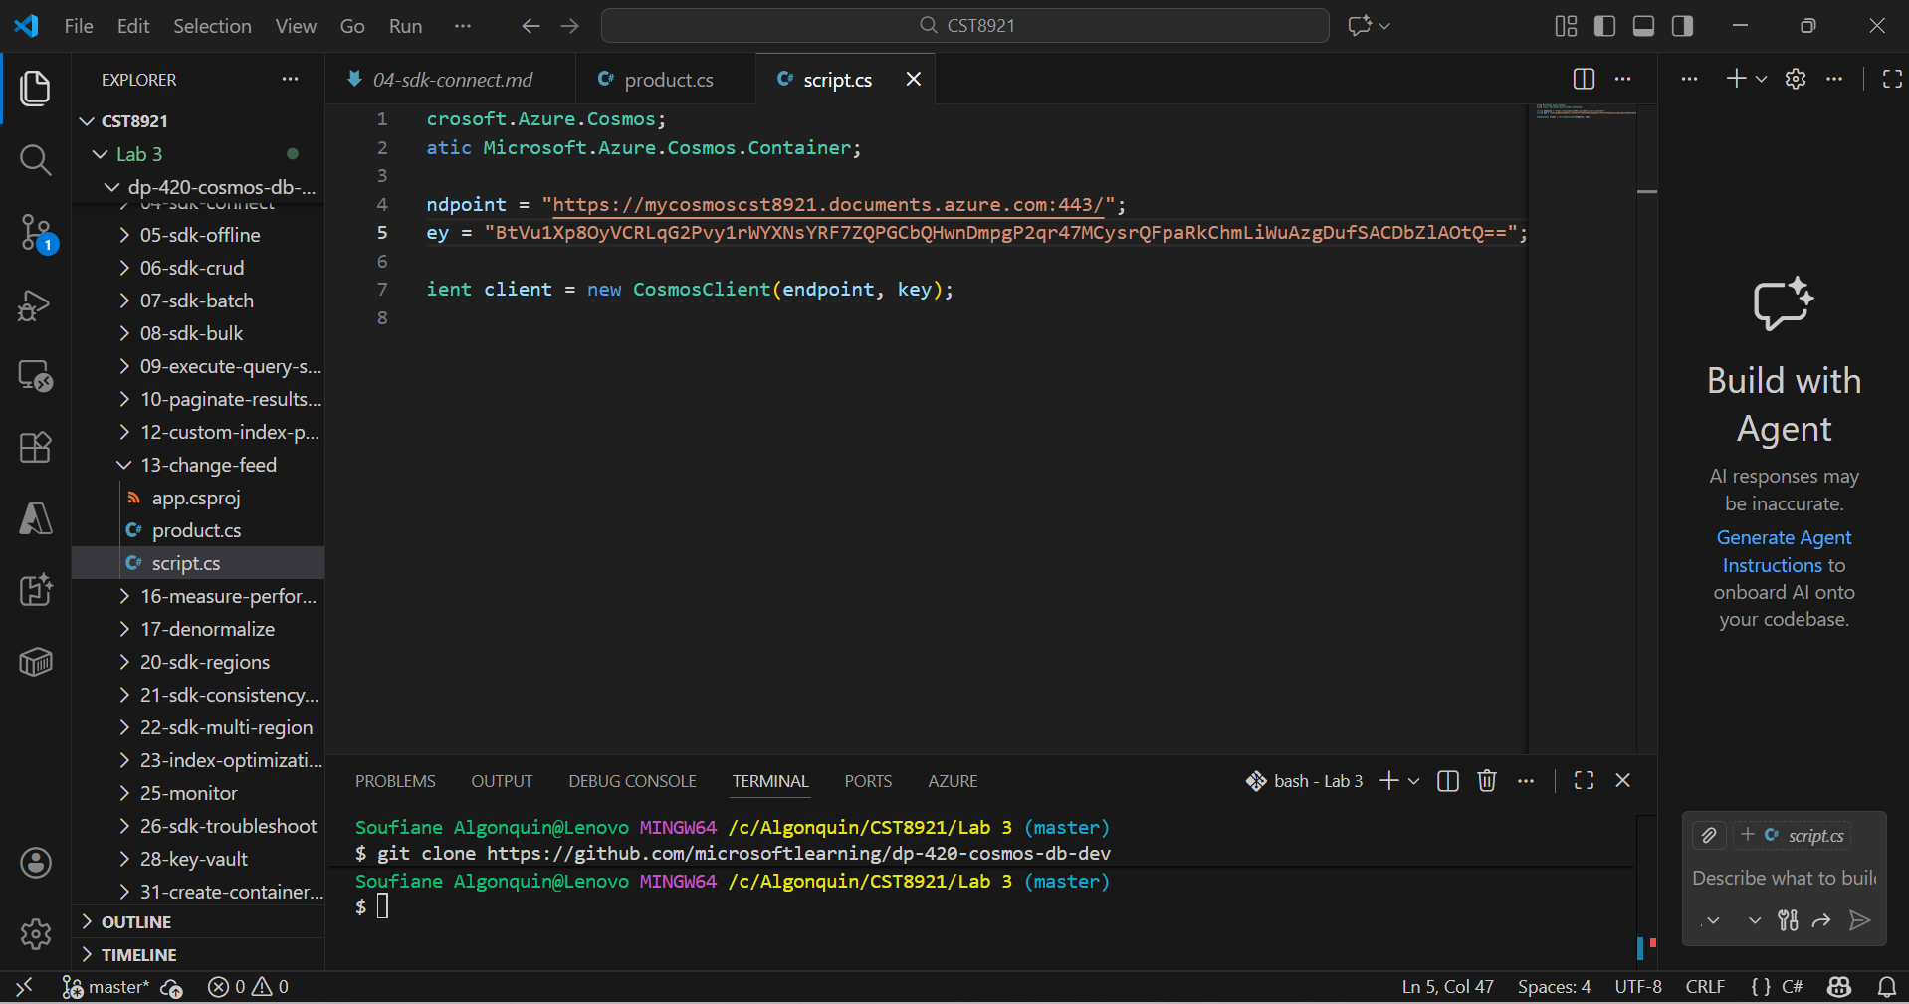

- Use the GetContainer method of the client variable to retrieve the existing container using the name of the database (cosmicworks) and the name of the container (products) and store the result in a variable named sourceContainer of type Container:

Container sourceContainer = client.GetContainer("cosmicworks", "products");

- Use the GetContainer method of the client variable to retrieve the existing container using the name of the database (cosmicworks) and the name of the container (productslease) and store the result in a variable named leaseContainer of type Container:
Container leaseContainer = client.GetContainer("cosmicworks", "productslease");

- Use this code and make the changes as per the instructions provided in previous steps:
using Microsoft.Azure.Cosmos;
using static Microsoft.Azure.Cosmos.Container;

string endpoint = "<cosmos-endpoint>";
string key = "<cosmos-key>";

CosmosClient client = new CosmosClient(endpoint, key);

Container sourceContainer = client.GetContainer("cosmicworks", "products");
Container leaseContainer = client.GetContainer("cosmicworks", "productslease");

ChangesHandler<Product> handleChanges = async (
IReadOnlyCollection<Product> changes,
CancellationToken cancellationToken
) => {
Console.WriteLine($"START\tHandling batch of changes...");
foreach(Product product in changes)
{
await Console.Out.WriteLineAsync($"Detected Operation:\t[{product.id}]\t{product.name}");
}
};

var builder = sourceContainer.GetChangeFeedProcessorBuilder<Product>(
processorName: "productsProcessor",
onChangesDelegate: handleChanges
);

ChangeFeedProcessor processor = builder
.WithInstanceName("consoleApp")
.WithLeaseContainer(leaseContainer)
.Build();

await processor.StartAsync();

Console.WriteLine($"RUN\tListening for changes...");
Console.WriteLine("Press any key to stop");
Console.ReadKey();

await processor.StopAsync();

Note : ChangeHandler () will delegate to receive the changes within a ChangeFeedProcessor execution.

- Save the script.cs file.
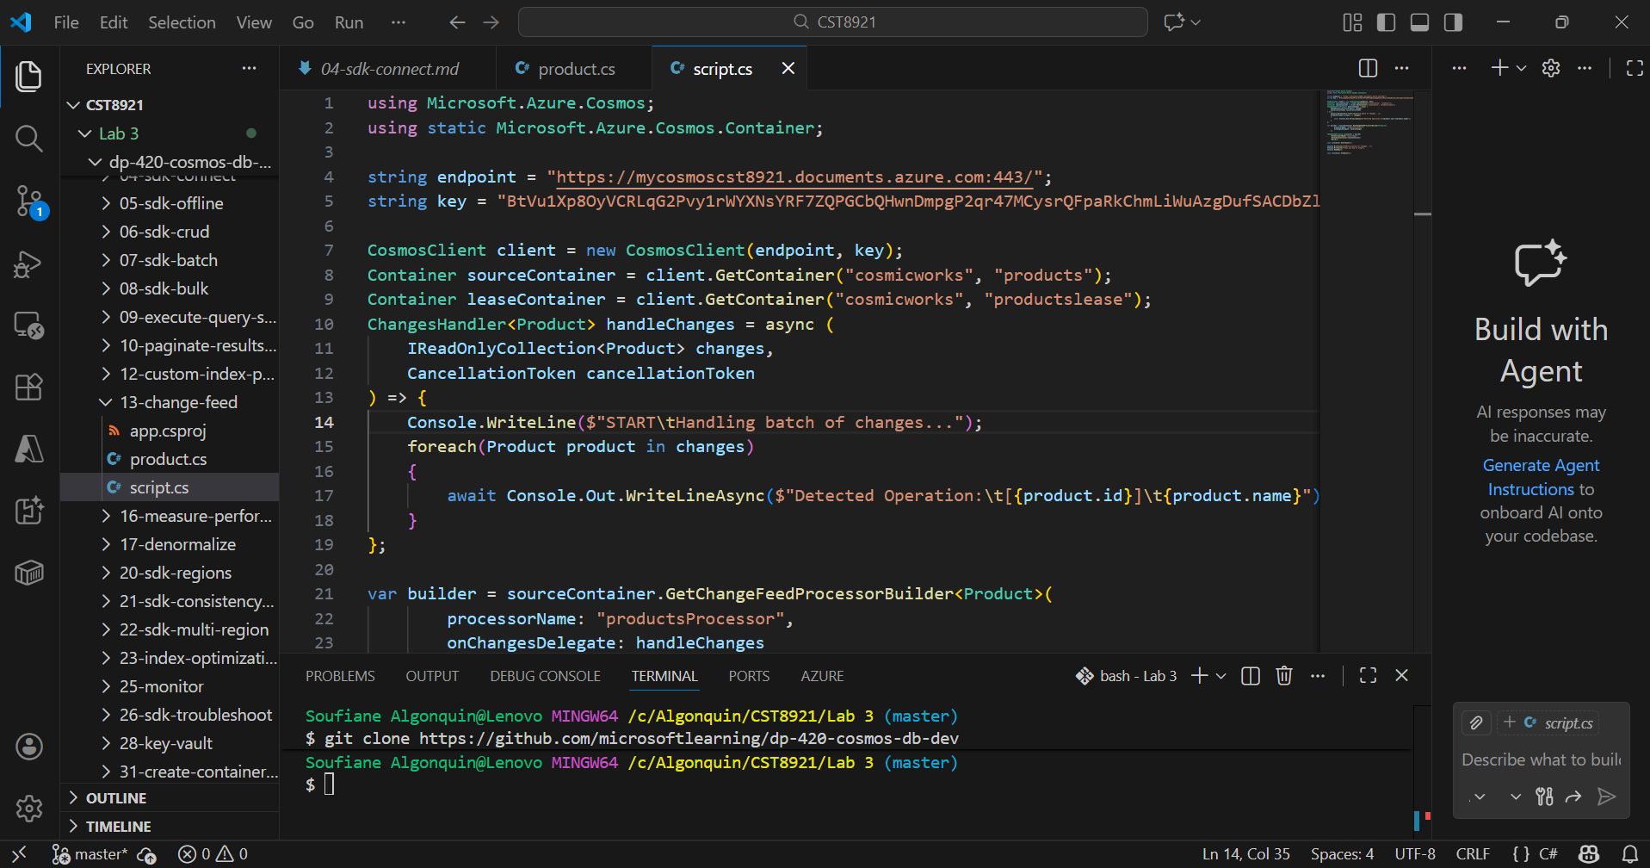

- In Visual Studio Code, open the context menu for the 13-change-feed folder and then select Open in Integrated Terminal to open a new terminal instance.
- Build and run the project using the dotnet run command:

dotnet run

- Leave both Visual Studio Code and the terminal open.
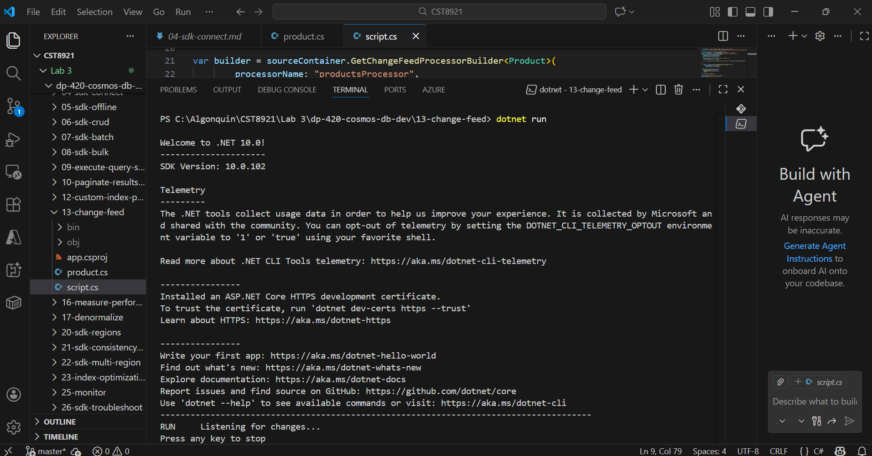
- Seed your Azure Cosmos DB for NoSQL account with sample data
- You will use a command-line utility that creates a cosmicworks database and a products container. The tool will then create a set of items that you will observe using the change feed processor running in your terminal window.
- In Visual Studio Code, open the Terminal menu and then select Split Terminal to open a new terminal side by side with your existing instance.
- Install the cosmicworks command-line tool for global use on your machine.
dotnet tool install cosmicworks --global --version 1.*
- Run cosmicworks to seed your Azure Cosmos DB account with the following command-line options:
cosmicworks --endpoint <cosmos-endpoint> --key <cosmos-key> --datasets product

- Wait for the cosmicworks command to finish populating the account with a database, container, and items.

- Observe the terminal output from your .NET application. The terminal outputs a Detected Operation message for each change that was sent to it using the change feed.
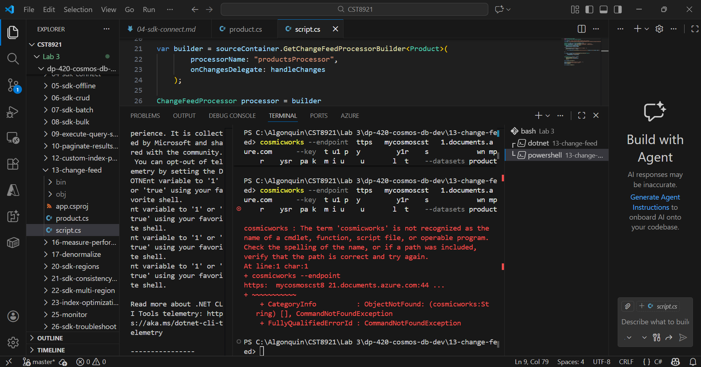

On Visual studio terminal I couldn’t run at all the command that starts with cosmisworks, therefore, I opted for windows PowerShell to run it.
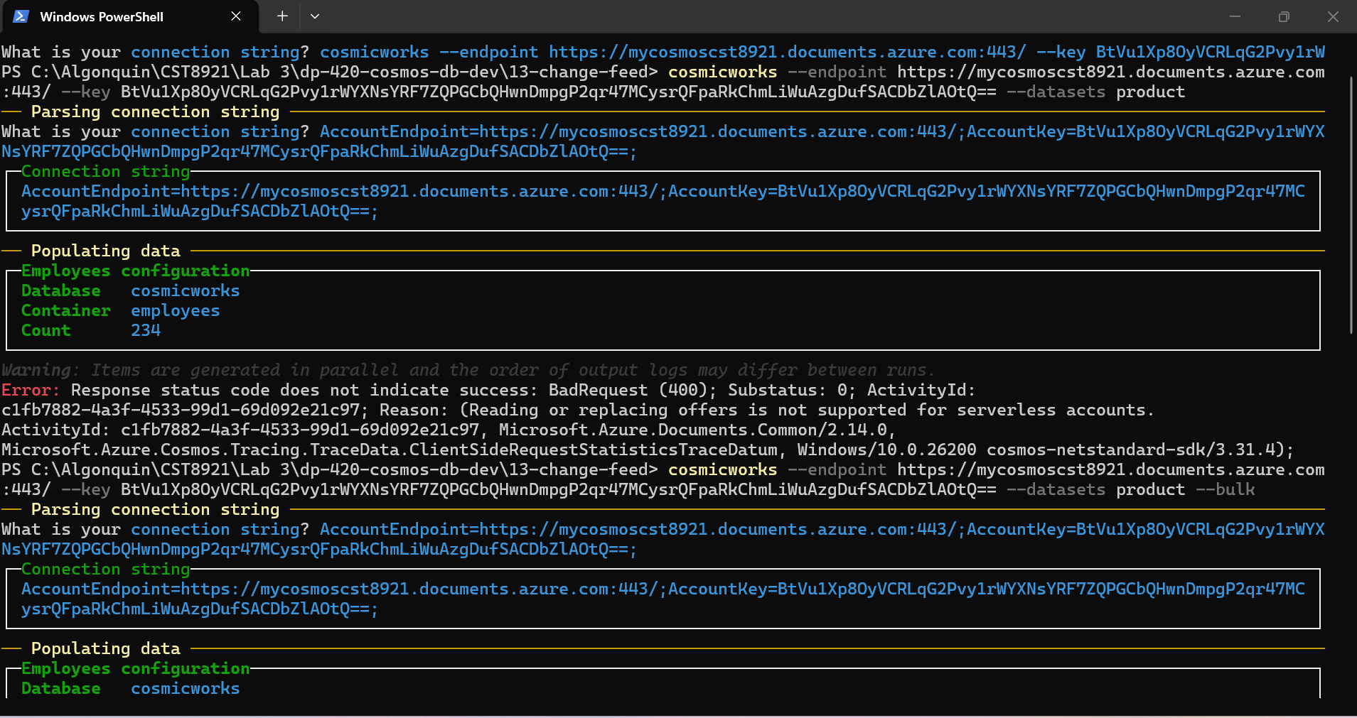
As you can see professor, I encountered a 400 BadRequest while running the cosmicworks command.
After troubleshooting, I understood the reason behind this error. Cosmicworks cmd is harde-coded to check for provisioned throughput, which is not supported on Serverless Cosmos DB account.
In order for it to work, we need to create a Cosmos DB account with provisioned throughput.
- Close both integrated terminals
- Verify the changes in product and productlease containers.
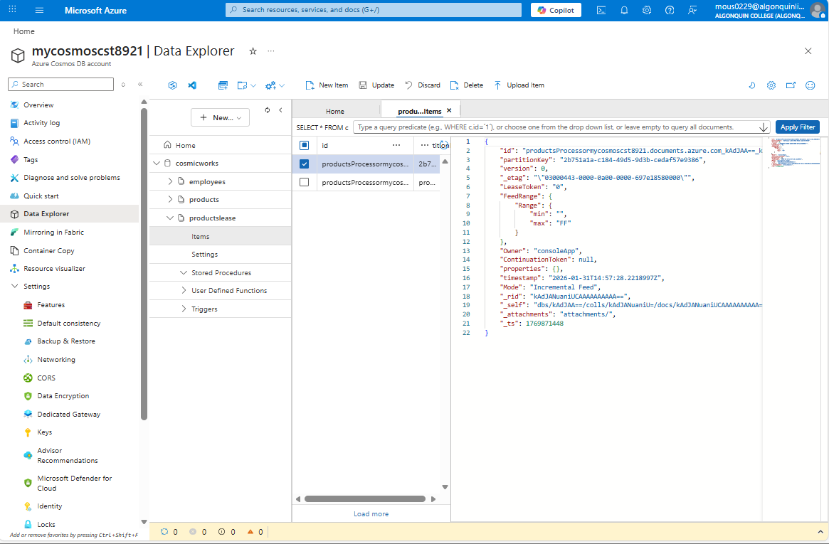

- Close Visual Studio Code.

Create an Azure Function app and Azure Cosmos DB-triggered function

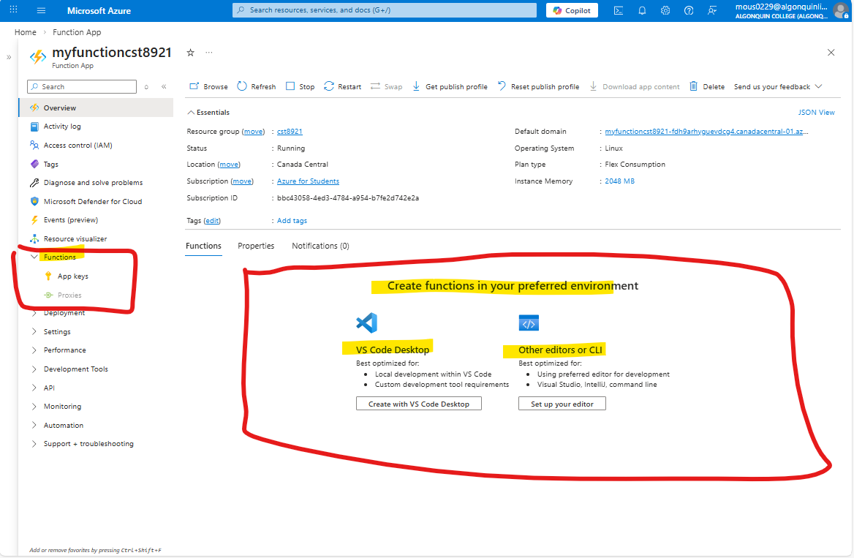

In the steps provided it mentions .Net version 6, currently the minimum version to use is .Net 8
Also, in the steps it says ‘go to Functions pane and select create’, it seems that Azure don’t support that anymore as you can see from the screenshot above.

The current way to do that now is to use VsCode as you can see the suggestion on the screenshot above,

